Rec/1/2 13th Nov 2017
Enhanced Provision

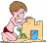  Sand  Tywod  Wet – create more complicated repeating patterns in the sand with the counters. | Water  Dŵr  Discuss capacity with the containers. | Art  Celf  Paint your own alien. Think about how many eyes, arms, legs, etc it will have. |   Malleable  Hydrin  Space play dough mats – discuss the different objects. E.g. What is a satellite? | Small World  Byd Bach  Space tray – create an imotion film using the astronauts.
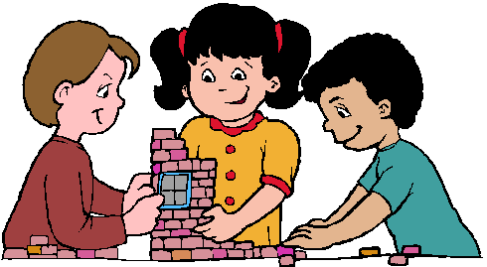  Construction  Adeiladu  Build a space rocket. Measure how tall your rocket is and record the length. | 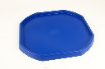  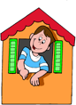  Role Play  Chwarae Rôl  Outdoor – Whatever Next! Cardboard box, owl, lunchbox, space helmet, etc.  Indoor – set up space rocket. | Tuff Spot  Hambwrdd Twff  Pudsey Bear – print with the cookie cutter/use the Pudsey template and finger print spots. 2 of each colour – count in 2s. | Mark Making  a b  c  Gwneud Marciau  Draw around the star template. Cut out and decorate your star. | Literacy  Iaith  Rainbow writing – HFWs.
Book Corner  Cornel Ddarllen  Read Beegu. | 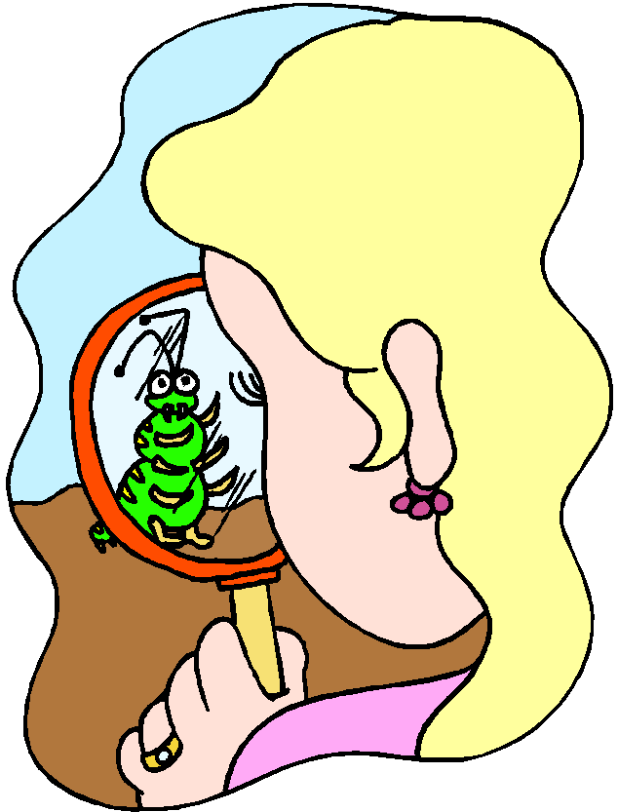  Investigation  Darganfod  What vehicles might you find in space? Read the information text and draw pictures of space vehicles. | Maths  1 2 3 4 5  Mathmateg  Multiplication/division game – 2 times table. | ICT    TGCh | 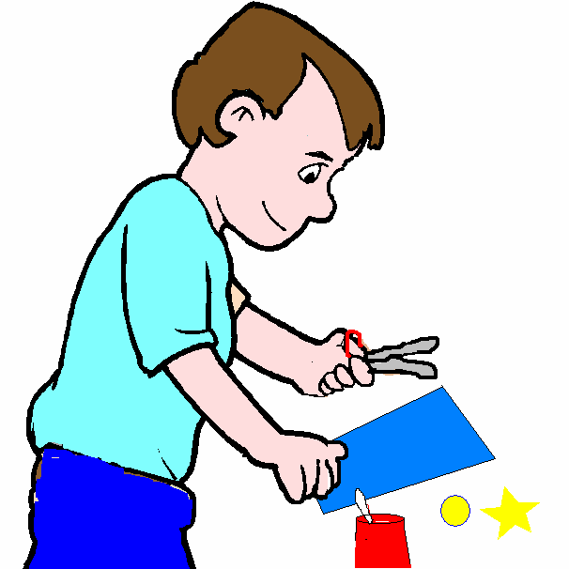  Make it table  Cornel Creu  Make a flying saucer by decorating and sticking two paper plates together.
Garden/Yr Ardd: mud kitchen, Pudsey Bear environmental art, splatter painting on the Perspex – rockets, QR code (Children in Need page).


