Rec/1/2 20th Nov 2017
Enhanced Provision

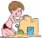  Sand  Tywod  Skill focus - MD  Car calculations – drive your car to the correct answer. | Water  Dŵr  Skill focus – KUW, MD  Explore the wet sponges and weighing scales. How much does a dry/wet sponge weigh? What’s the weight difference? | Art  Celf  Skill focus – CD, PD  Paint a picture of Beegu. |   Malleable  Hydrin  Skill focus – CD, PD  Use the playdough/googly eyes/limbs/etc to make Beegu. | Small World  Byd Bach  Skill focus – PSD, LLC  Create a road for the cars to travel along. Use the small world characters to act out crossing the road safely.
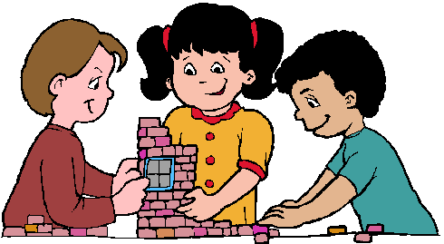  Construction  Adeiladu | 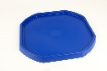    Role Play  Chwarae Rôl  Skill focus - MD  Space rocket – put the counting in 2s/5s/10s ping pong balls down the tube in the correct order. | Tuff Spot  Hambwrdd Twff  Skill focus – KUW, PSD  Road signs matching game. | Mark Making  a b  c  Gwneud Marciau  Skill focus – LLC, PD  Practise letter formation in the cornflour mix. | Literacy  Iaith  Skill focus – LLC, PSD  Road safety word search
Book Corner  Cornel Ddarllen  Skill focus – LLC, KUW  Space topic books. | 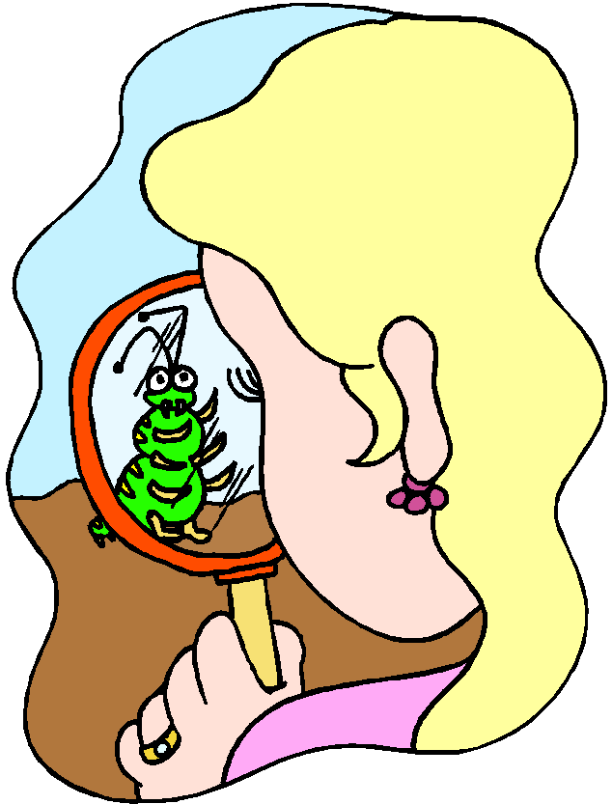  Investigation  Darganfod  Skill focus – LLC, KUW  What interesting facts can you find in the space non fiction texts? | Maths  1 2 3 4 5  Mathmateg  Skill focus - MD  Representing numbers in different ways (visuals).  --------------------------  Splat the number that is 1/2/10/20 more or less. | ICT    TGCh  Skill focus – ICT, PSD, CD  Use j2e on Hwb to draw a space rocket or planet.  ---------------------------  Scan the QR code to find out about road safety. | 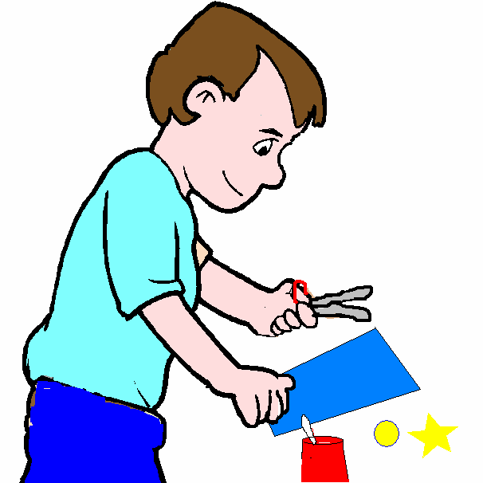  Make it table  Cornel Creu  Skill focus – CD, PSD  Make a space rocket with the junk modelling.
Garden/Yr Ardd: variety of construction resources, fairy figures, dinosaurs, flick painting on the Perspex, mud kitchen. Wash waterproofs in the water tray towards the end of the week.
Yard: road crossing resources, bikes and physical box.

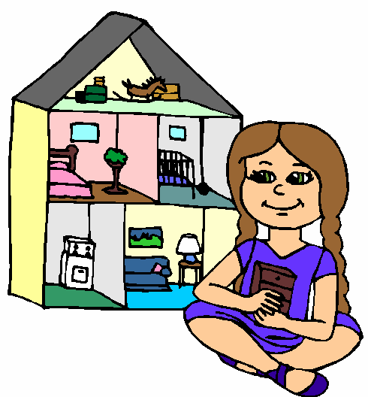
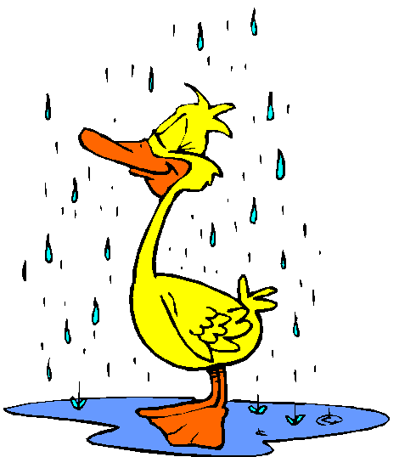
Areas of Learning
PSD = Personal and Social Development, Wellbeing and Cultural Diversity LLC = Language, Literacy and Communication
MD = Mathematical Development KUW = Knowledge and Understanding of the World
PD = Physical Development CD = Creative Development
WLD = Welsh Language Development

Plus ICT and RE

