Rec/1/2 4th Dec 2017
Enhanced Provision

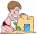  Sand  Tywod  Match capital letters to lower class letters – Christmas crackers. |   Water  Dŵr  Explore the fake snow. | Art  Celf  Paint a picture of your character in the Christmas concert.  Paint the nativity scene. |   Malleable  Hydrin  Christmas playdough mats. |   Small World  Byd Bach
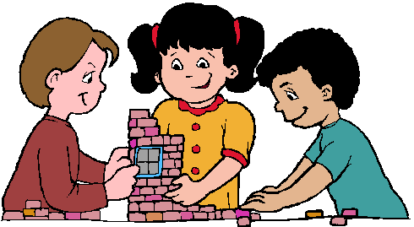  Construction  Adeiladu  Build a sleigh for Father Christmas. | 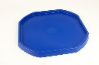  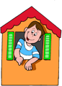  Role Play  Chwarae Rôl | Tuff Spot  Hambwrdd Twff  Nativity small world – role play the story. | Mark Making  a b  c  Gwneud Marciau  Draw around the stocking template, cut out and decorate. | Literacy  Iaith  Write a letter to Father Christmas.  Twinkle Christmas workbook.
Book Corner  Cornel Ddarllen  Christmas story books. | 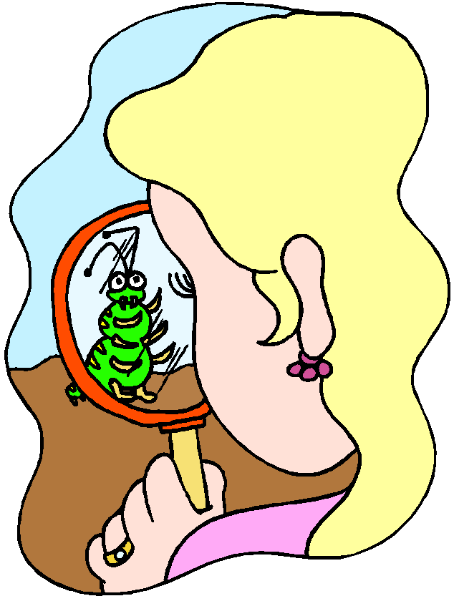  Investigation  Darganfod | Maths  1 2 3 4 5  Mathmateg  Roll and cover/answer a calculation and cover the answer on Father Christmas’ beard.  Twinkle Christmas workbook. | ICT    TGCh  Use j2e to draw a Christmas tree.  Maths QR code. | 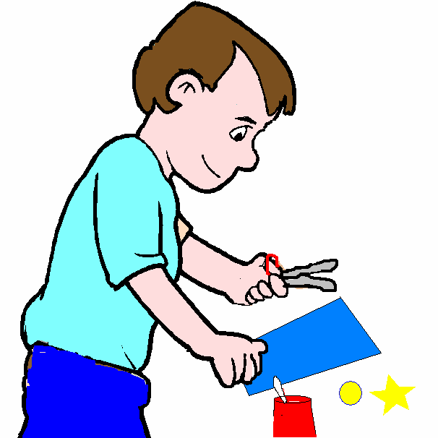  Make it table  Cornel Creu  Christmas stocking threading cards.  Christmas tree cone craft.  Lollipop stick stable scene.
Yard: dice addition and chalk, chalk Christmas trees, reading pods.

