Reading  Darllen | Mark Making  Gwneud Marcio | Literacy  Iaith | Role Play  Chwarae Rol
Read Jack and the Beanstalk. | Practise your spelling words in the yellow sand. | Sort the true or false statements. Set 1. | Explore the new role play area (when it is ready!)
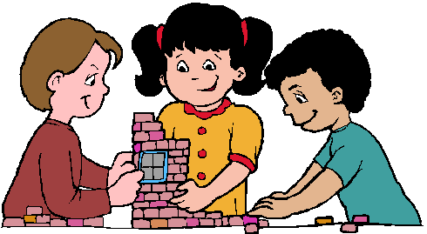  Construction  Adeilidau | 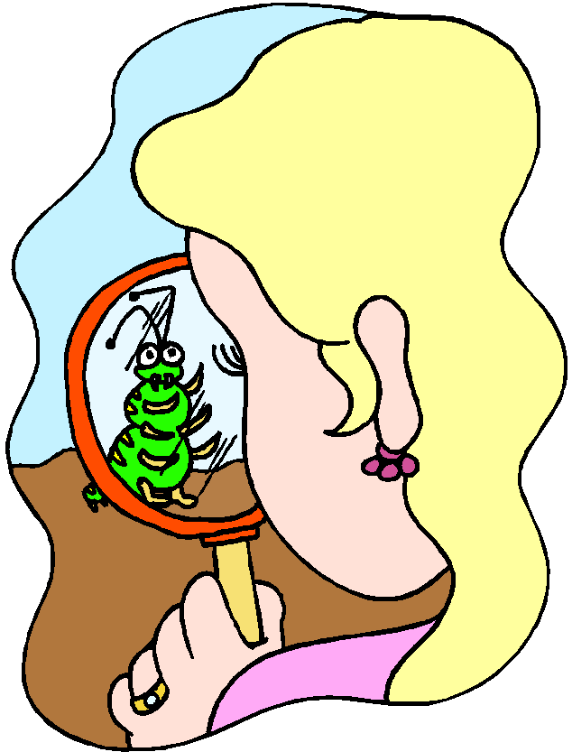  Investigation  Darganfod | Maths  Mathemateg | 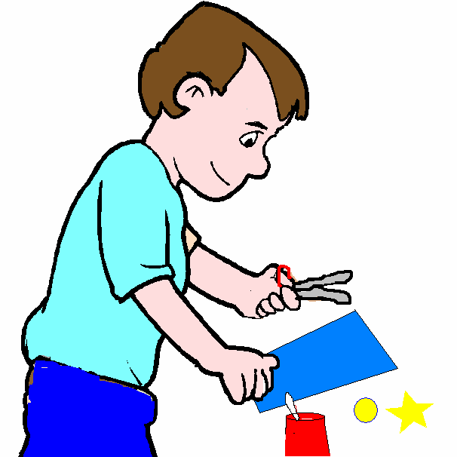  Creative  Creu
Build a beanstalk for Jack to climb. Measure how tall it is and record. | Look closely at the different plants and draw what you see. | Times table board games OR addition/subtraction board games. | Jack and the Beanstalk colouring pages.
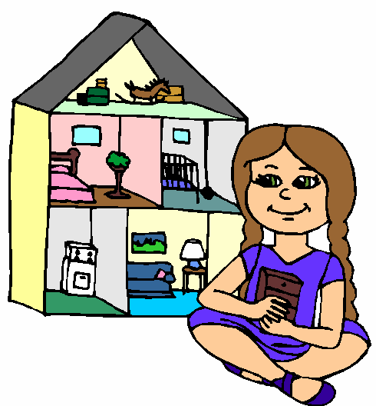  Small World  Byd Bach | ICT  TGCh | Funky Fingers  Bysedd Prysur | Table Top Games  Gemau bwrdd
 | Use j2e to draw the Giants castle in the clouds. |  | Free choice.

Water  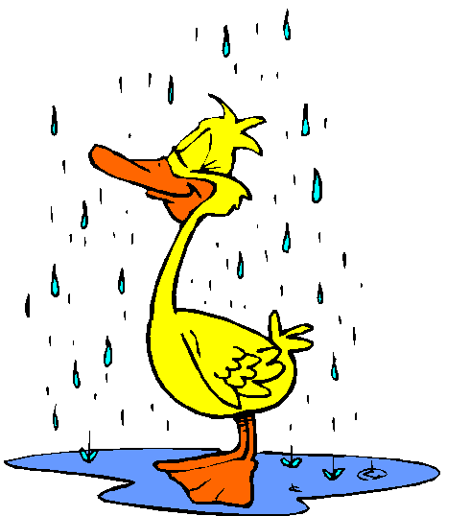  Dwr |   Sand (Dry)  Tywod (Sych) | Sand (Wet)  Tywod (Gwlyb)
Explore the 2D shapes in the soapy water. Talk about the properties of the shapes. | Choose your favourite sand resources. | Choose your favourite sand resources.
Construction  Adeilidau | Mark Making  Gwneud Marcio | Creative  Creu
Create a home for a story character. | Continuous provision – paper and mark making resources in Mrs Kay’s class. | Look at the different 3D shapes in the junk modelling to create a model.
Small World  Byd Bach | Digital  Digidol |   Malleable  Toes
Choose your favourite small world resources to make a story. | Use the iPads to create your own story. | Explore the shapes with the playdough.

