Sialens 1  Gwyliwch y clip fidio ar Pod Antur 1 a rhowch gynnig ar wrando ar y straeon.  Watch the video clip on Pod Antur 1 and have a go at listening to the short audio stories.  Follow the link  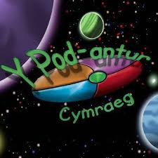  https://www.podantur.com/packs/pack-1/ | Sialens 2  Chwaraewch y gêm fidio ar Pod Antur 1.  Play the video game on Pod Antur 1.  Follow the link    https://www.podantur.com/packs/pack-1/ | Sialens 3  Teimladau! Gwyliwch y fidio ar Bitesize a rhowch gynnig ar y tasgau.  Feelings! Watch the video on Bitesize and attempt the tasks.  Follow the link  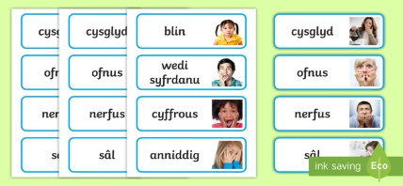  https://www.bbc.co.uk/bitesize/topics/z4vs6v4/articles/zngsxyc | Sialens 4  Gwyliwch Criw Celf a gwnewch wynebau eich hunain a’u labelu.  Watch Criw Celf and create your own faces. Label them and send them to us on @athrawonbro    https://tinyurl.com/y96dsnju | Sialens 5  Rhowch gynnig ar app newydd- Aur am Air.  Try out our a new app and practice your spelling skills – Aur am Air.  
Sialens 6  Canwch a dawnsiwch efo Mr Urdd!  Sing and dance with Mr Urdd!    http://tinyurl.com/ycmana7c | Sialens 7  Gwyliwch y fidio ar Bitesize ac ewch ati i wneud smŵddi eich hun.  Watch the video on Bitesize and make your own smoothie. Take a photo and send it to us on @athrawonbro    https://tinyurl.com/y7es6dza | Sialens 8  Cadwch yn heini yn Gymraeg! Keep fit in Welsh! Follow the link below for many workouts suitable for all.    https://tinyurl.com/ycaz3rsu | Sialens 9  Triwch Ap Iaith i wella eich Cymraeg mewn parc thema  Try the Ap Iaith theme park tasks where you can improve your Welsh skills  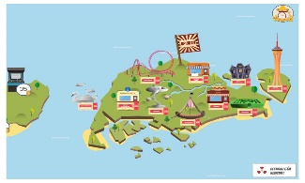 | Sialens 10  Amser Cerddoriaeth. Gwrandewch ar fandiau Cymraeg.  Listen to some Welsh playlists. Follow the link below    https://tinyurl.com/ycsemnys

